Curriculum Vitae

Lala ram
Mb.No. +91-9718486407
Email:Lalaramverma54@gmail.com
OBJECTIVE

I want to be in an organization which provides me with the immense Opportunities to learn, grow and to apply my technical skill and establish me as a Professional.

EMPLOYEMENT DETAILS
Present:

WORKING WITH JAQUAR GROUP OF COMPANIES at ESSCO SANITATIONS AS HR EXECUTIVE –PAYROLL & Admin
- Handle the all activity related to time office , leave updation, gate pass, late coming , over time employee set up in payroll with master data.
- Preparation of salary and payment of all reimbursement.
- Disbursement of salary slips and handle query.
- Reconciliation of salary payment, loan payment and advance with A/c Deptt.
- Maintain the Statutory compliances PF, ESIC and Factory Act Return within time.
- Preparation of Full &Final settlement and other exit formalities.
- Maintain employee personnel file /records in master data base.
- Prepare HRIS and coordinate with seniors as well other departments.
Handle the all joining responsibilities, drafting the offer letter, appointment letter, confirmation letter and experience letter.
- Update the personnel records in master data base.
- Employee counseling and training feedback preparation through HRIS share with seniors.
- PLANT ADMINISTARTION
- Handling the Attendance, late coming, gate pass & official duty also maintain HRIS.
- Plan and implement office systems, layout and equipment procurement & maintain office equipment.
- Plant security proper arrangements of guards on all positions and also work on night shift reports
- Proper coordination with canteen staff for smooth running.
- Handle the plant housekeeping separate HRIS present to management.
Previous
SHARDA & COMPANY (JOB CONTRACTOR) DEPUTED AT MSIL GURGAON &MANESAR ON THIRD PARTY ROLE

Working As, (HR EXECUTIVE) fromNov 2010 in MSILin HREDeptt.Onbehalf of Sharda & Company.
- Handling the Attendance, late coming, gate pass & official duty also maintain HRIS.
- Updation of leaves and other attendance regularization request after approval ofmanagements.
- Disbursement of salary slips and makes ensure about timely payment.
- Handling queries regarding Salaries, PF & ESIC.
- Payment of LTA, Medical Reimbursement, local Conveyance.
- Updation of employee’s personnel record in master data base (ERP).
- Maintain personnel files with all joining formalities.

PROFESSIONAL & EDUCATIONAL QUALIFICATIONS
- 1 Year Diploma in A.D.C.A (ADVANCE DIPLOMA IN COMPUTER APPLICATION) from RGCSM, Atrauli Aligarh up.
- Intermediate (Science stream) from CBSE Board New Delhi In 2006
- Matriculation (Science stream) fromCBSE Board New Delhi In 2004
OTHER SKILLS

- Good command of excel, world, PowerPoint & Microsoft outlook.
- Well knowledge of Internet and outlook
.
SOFT SKILLS

- Willing to accept responsibilities.
- Good interpersonal skills and a pleasing personality.
- Good listener, very observant and quick learner.
- Confident, self-starter, honest & sincere person and interested in secretarial fields.
PERSONAL DOSSIER

Date of Birth : 15-oct-1989
Father Name : Sh .Raj Veer Singh
Gender : Male
Passport no. : L1896884
Marital Status : Married
Nationality : Indian
Linguistic Abilities : English, Hindi, Urdu
Expected Salary : Negotiable
Permanent Address : VILL- Bahravad, POST-Atrauli, DIST-Aligarh (UP)

Reason for Leaving : Looking for great opportunities.

Current CTC : 3.25 Lac. /annum

Place: Delhi

Date:
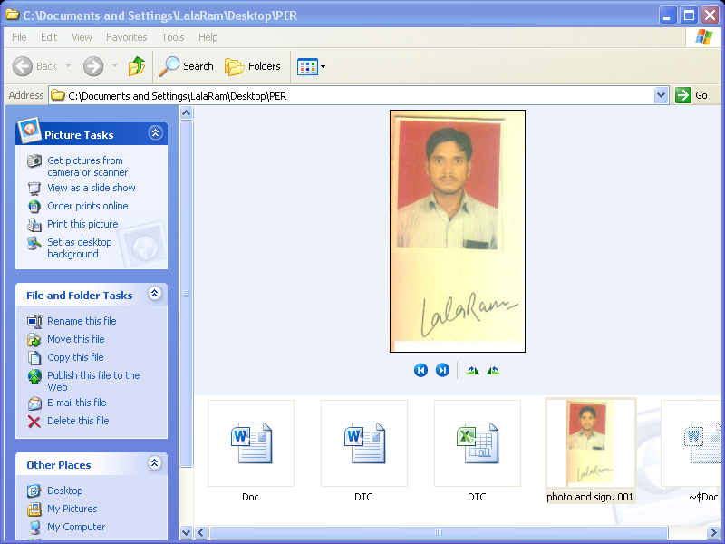

LALARAM

